LAB 6: CODE AND BRANCH COVERAGE ANALYSIS
Amusement Park Ride Access
Name: Samyuktha Vadrevu
SRN: ____________________
Course/Lab: Software Engineering – Lab 6
Date: 29 October 2026

1. Objective
To measure code coverage and branch coverage for the Amusement Park Ride Access program, identify untested code paths, and improve test completeness using pytest and the coverage tool.

2. Tools Used
- Python 3.12.10
- pytest 9.2.0
- coverage.py
- Visual Studio Code / PowerShell

3. Files Used
- amusement_park_ride_access.py – application under test
- test_amusement_park.py – starter test file
- CodeCoverageTest_amusement_park_ride_access.py – additional tests for code coverage
- BranchCoverageTest_amusement_park_ride_access.py – separate tests for branch coverage

4. Procedure
- Installed the required testing tools using pip: pytest and coverage.
- Ran the starter tests and generated an initial coverage report.
- Added test cases for invalid input, closed rides, ride types, patron height and health restrictions, fast-lane admission, safety audit status, and restraint sensor conditions.
- Ran the code coverage tests and checked the report using coverage report -m.
- Ran the separate branch coverage tests with the --branch option and checked the branch report.

5. Results and Analysis
Metric | Initial result | Final result
Application statement coverage | 48% | 100%
Total statements | 58 | 58
Missed statements | 30 | 0
Branch coverage | Not measured initially | 100%
Branches | Not measured initially | 40
Partial branches | Not measured initially | 0
Tests in coverage test file | — | 12 passed
Tests in branch coverage test file | — | 12 passed
The initial report showed 48% statement coverage for the application. After adding targeted test cases, the application reached 100% statement coverage with 0 missed statements. Branch coverage was then measured separately using the --branch option. The final report showed 40 branches, 0 partial branches, and 100% coverage.

6. Test Scenarios Covered
- Invalid groups input and negative express-pass fee
- Closed rides and supported/unsupported ride types
- Patron height validation, child pricing, and health warnings
- Roller-coaster safety restriction and fast-lane fee
- Safety audit and completed/zero-admission statuses
- Empty restraint data, emergency lock, and safe restraint readings

7. Evidence Screenshots
The screenshots below show the initial test and coverage result, followed by the final code coverage and branch coverage results.
Screenshot 1
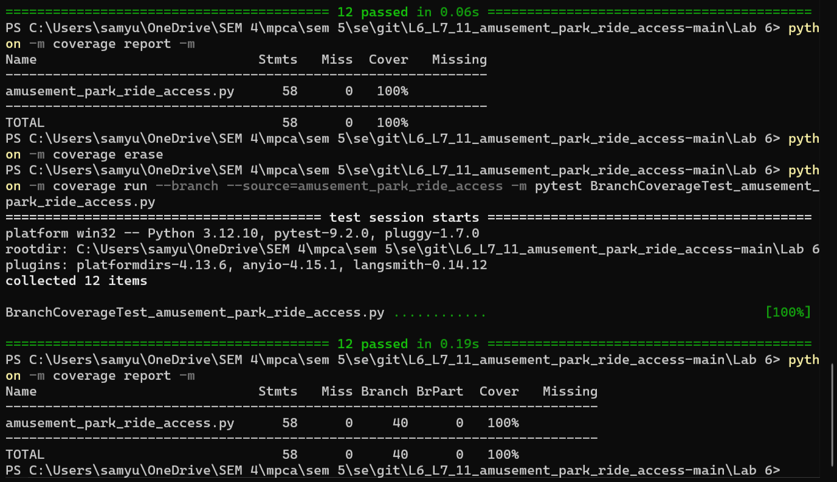

Screenshot 2
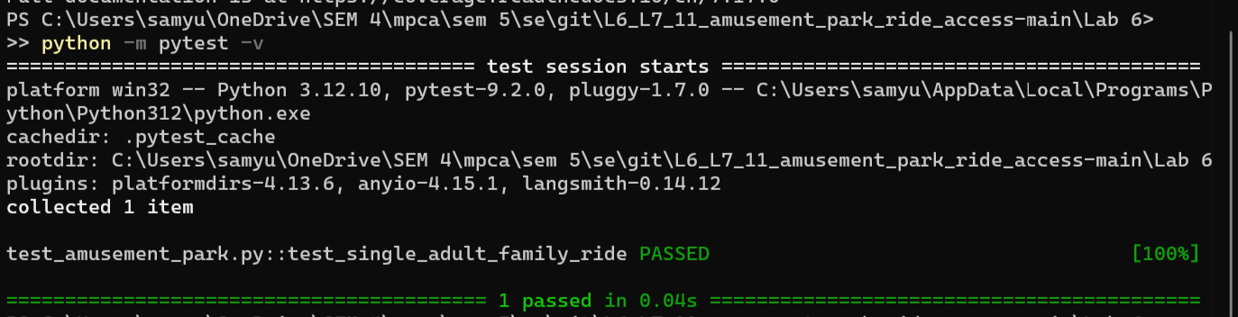

Screenshot 3
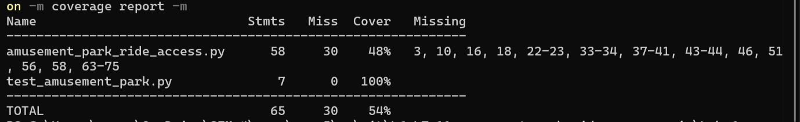

Screenshot 4
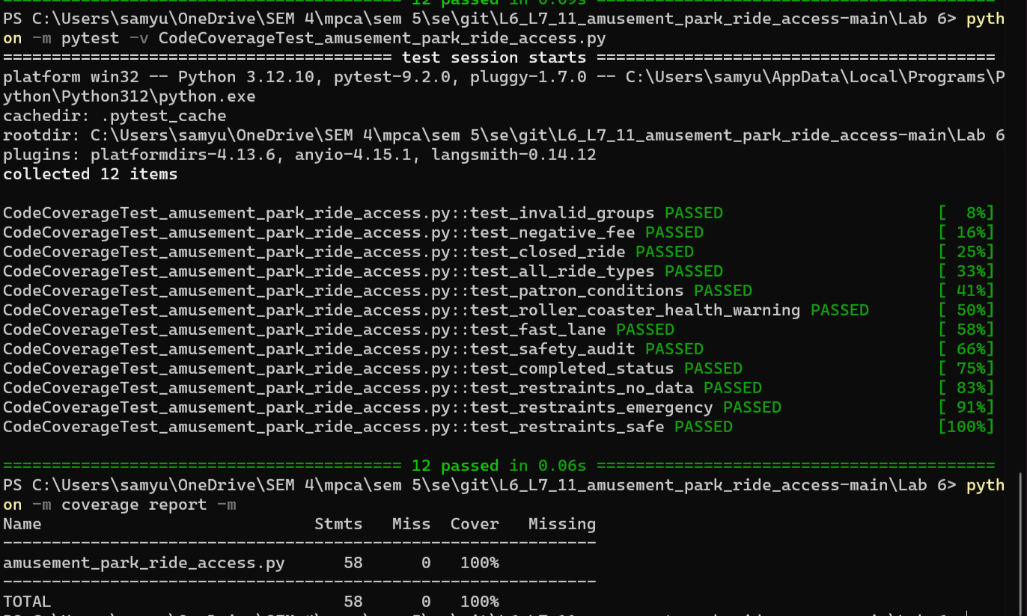

8. Conclusion
The lab exercise demonstrated how line/statement coverage differs from branch coverage. The added tests exercised the application's statements and decision branches, achieving 100% statement coverage and 100% branch coverage in the final reports. The required separate test files were created for code coverage and branch coverage.

